BigMart Sales Prediction – Hackathon Approach Note
1. Problem Understanding
The objective was to predict Item_Outlet_Sales for products across different outlets. This is a supervised regression problem using structured tabular data comprising:
- Item-level attributes (MRP, type, visibility, fat content, weight)
- Outlet-level attributes (size, type, location, establishment year)
- Historical sales
The evaluation metric was Root Mean Squared Error (RMSE)
2. Exploratory Data Analysis (EDA)
Using Pandas profiling and distribution plots, I conducted structured EDA to understand data behavior and quality.( refer to file : EDA_bigmart_profile)
Key observations:
- Sales distribution was right-skewed.
- Item_MRP showed strong correlation with sales.
- Outlet-level variables (size, type, establishment year) were correlated.
- Missing/zero values existed in:
  - Item_Weight
  - Outlet_Size
  - Item_Visibility
- Item_Fat_Content required standardization.
- Certain Item_Type categories needed grouping due to skewed frequency distribution.
These findings directly guided feature engineering and modeling decisions.
3. Data Preprocessing & Feature Engineering
Data Cleaning
- Standardized categorical inconsistencies (e.g., Item_Fat_Content).
- Imputed:
  - Item_Weight using item-level mean.
  - Outlet_Size using outlet-type grouping.
- Replaced zero Item_Visibility with item-level average visibility.
Feature Engineering
- Created Outlet_Age = Current_Year - Outlet_Establishment_Year.
- Built Visibility_Ratio = Item_Visibility / Average_Item_Visibility.
- Extracted Item_Category from Item_Identifier.
- Created outlet-level aggregate features:
  - Outlet_Average_Sales
  - Outlet_Item_Count
- Applied target encoding to Outlet_Identifier to capture store-level sales behavior.
- Explored transformations and interactions:
  - Polynomial terms of Item_MRP
  - Log of MRP
  - Log transformation of target
  - Interaction between Item_MRP and outlet-level aggregates
These features helped capture strong price-driven and store-level effects.
4. Model Experimentation Strategy
I experimented with both bagging and boosting approaches:
- Linear Regression (baseline)
- Random Forest
- LightGBM
- XGBoost
- Ensemble of Random Forest + LightGBM
Observations:
- Tree-based models significantly outperformed linear models.
- Simple weighted averaging provided modest improvements.
- Meta-model stacking did not add value due to high correlation between base models and risk of overfitting.
- Final chosen model: Random Forest (best bias-variance tradeoff in CV).
5. Validation & Hyperparameter Optimization
- Used 5-Fold Cross-Validation for robust performance estimation.
- Hyperparameters tuned using Optuna with 5-fold CV, optimizing:
The optimization objective was minimizing mean CV RMSE.
6. Error Analysis & Iterative Refinement
Performed structured error analysis to:
- Identify high-error sales zones.
- Detect feature instability across folds.
- Evaluate necessity of transformations and interaction terms.
This analysis led to selective addition of price transformations and outlet-level encoding while avoiding excessive feature engineering.
7. Key Insights
- Item_MRP is the strongest predictor.
- Outlet-level behavior significantly impacts sales.
- Target encoding of outlet improves predictive stability.
- Over-engineering interactions does not necessarily reduce RMSE.
- Controlled regularization and proper CV strategy are critical for stable performance.
8.Conclusion:
After extensive experimentation across multiple modeling approaches, the final selected model was Random Forest, achieving a cross-validated RMSE of approximately 1015. This model demonstrated the best balance between bias and variance, stable cross-validation performance, and consistent generalization across folds.
On submission to the hackathon leaderboard, the model achieved a public score of 1155

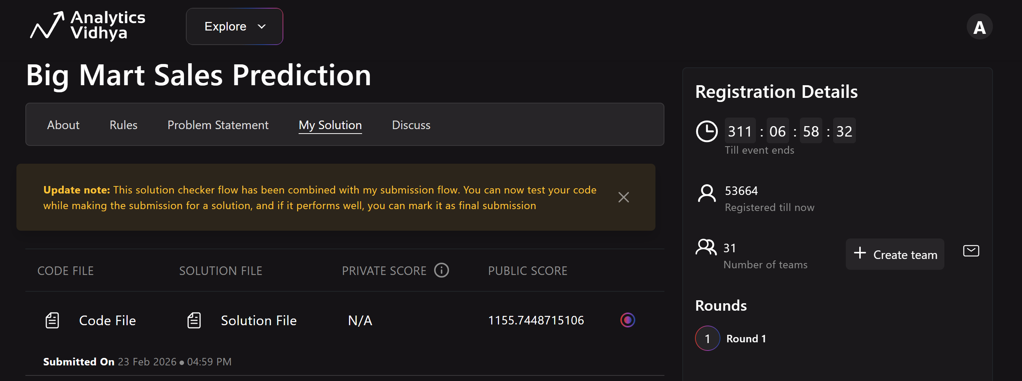

Note:
BigMart_Sales_RF_Model_Final Model: Notebook with final Feature engineering and final Model
BigMart_Sales_Stack_Model: Notebook where experiment related to stacked model done
BigMart_Sales__Experiments: Notebook where all kinds of modelling experients have been conducted
EDA_bigmart_profile: Output of EDA

